Antioxidants: Nature's Own Protection For Your Horse
Drs. Foster & Smith Educational Staff
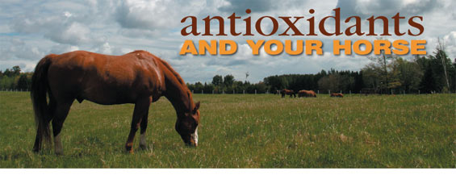
Antioxidants are important for your horse on many levels. Nature supplies antioxidants to protect us from the destructive effects of environmental free radicals. Free radicals are caused by ultra-violet rays from the sun, x-rays, exposure to pesticides, insecticides, herbicides and more.
What's more, free radical damage accumulates with age. Using antioxidants helps slow down and prevent free radical damage that speeds up aging and cell damage. In this process the antioxidant gives one of its electrons to the free radical thereby neutralizing its damaging effect. Since the antioxidant is no longer functional once it gives up the electron, antioxidants need to be given on a regular basis.
Antioxidants may be in the form of vitamins, minerals, plant extracts, and other substances. The antioxidants work together to neutralize free radicals. Each one works in a slightly different pathway, so it is best to administer several antioxidants rather than all one kind. Some common antioxidants used in horses, and their major functions, are listed below.
Antioxidant | Function
Vitamin C | Vitamin C particularly binds to nitrates, which play a role in the development of some cancers. It is also called ascorbic acid or sodium ascorbate.
Vitamin E | Vitamin E is fat soluble and protects the lipid (fat) parts of the cells such as cell walls and cell membranes. Also called alpha-tocopherol. The Vitamin E requirements for performance and endurance horses are higher than those horses getting less exercise.
Beta-carotene | Beta-carotene is a form of Vitamin A. It is one of the most effective and efficient scavengers of a free radical called 'singlet oxygen.'
Zinc | Zinc is a mineral that helps to maintain the health of cell membranes, protecting them from injury from free radicals.
Selenium | Selenium is a mineral needed by the body to synthesize sufficient amounts of glutathione peroxidase, which is an important antioxidant enzyme that protects against free radical damage. Works synergistically with Vitamin E. In many areas, selenium is deficient in the soil and in plants. Selenium can be toxic at high levels, however, so be aware of all sources of selenium in your horse's diet. Consult your veterinarian if there is concern about selenium deficiency or toxicity.
Grape seed extract | Grape seed extract contains proanthocyanidins, which are a type of flavonoid. They are not only antioxidants, but also appear to protect the heart, liver, and capillaries. It is especially helpful in preventing the oxidation of fats, including fatty acids.
Benefits of Antioxidants
Antioxidants protect the body from free radicals, which can increase the risk of cancer, and accelerate the aging process. Antioxidants may slow the progression of some of the behavioral changes we see in older animals. Antioxidants reduce damage to the liver from certain drugs or toxins.
Which horses may benefit from supplemental antioxidants?
Virtually any horse can benefit from antioxidants. Those horses for which antioxidant supplements are often recommended include:
- Horses under stress
- Horses in training or competition (racing, performance horses, and endurance horses)
- Breeding horses
- Growing horses
- Older horses
- Horses with inflammatory diseases such as arthritis
- Horses with diabetes mellitus
- Horses with autoimmune diseases
Remember that each antioxidant works differently, so it is best to use a combination on your horse.

